Making equal groups: grouping and sharing:
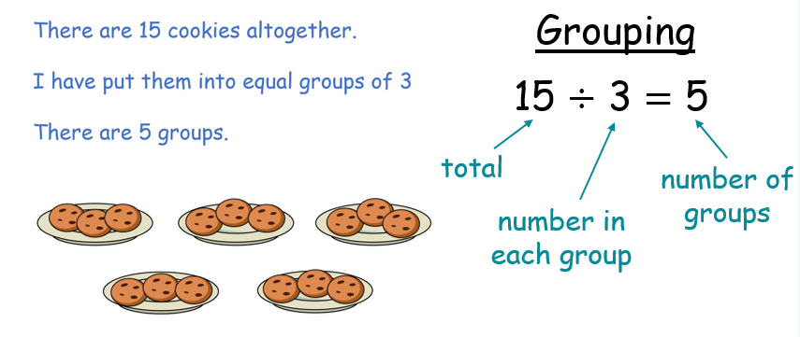

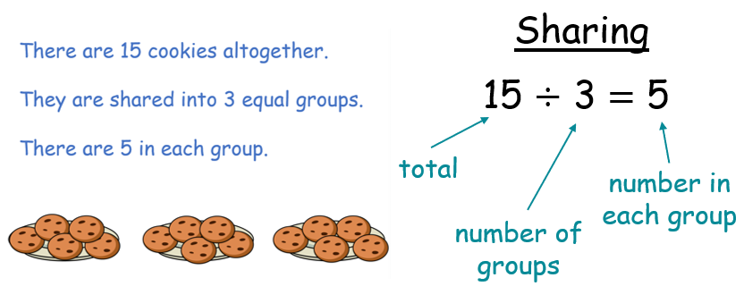

To help your child identify whether a division problem is grouping or sharing, encourage them to think about whether they are making equal groups from a total (grouping) or sharing a total equally between people or groups (sharing).

