Sharing and Grouping activities:
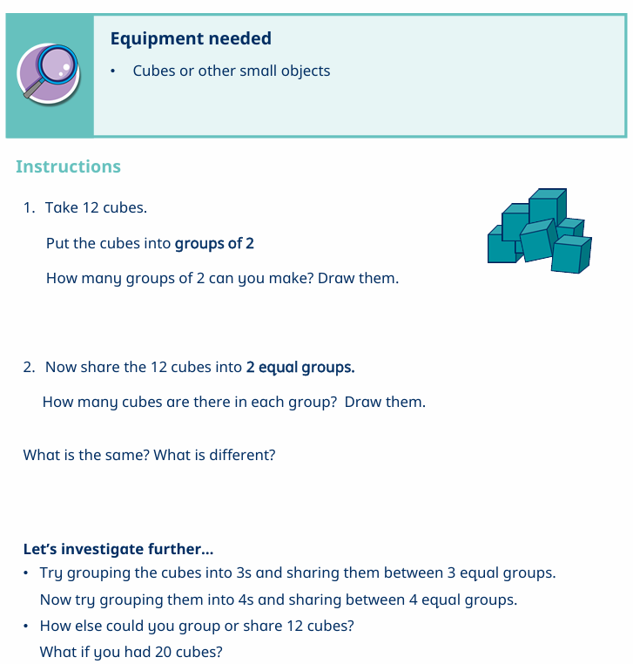

Sharing:

Snack Sharing (Key Activity)
- Give 12 grapes or pieces of pasta or smarties
- Ask:
“Can you share these between 3 people?”
- Deal them out one at a time into 3 piles
Ask:
- “How many in each group?”
- “Is it equal?”

Teddy Bear Picnic
- Set up teddies and “food”
- Example:
  - 8 biscuits, 4 teddies
Ask:
- “How many does each teddy get?”

Grouping:

Group the Treats
- Give 12 grapes or smarties
- Ask:
“Can you make groups of 3?”
Ask:
- “How many groups did you make?”

Toy Sorting Challenge
- Example:
  - 10 cars into groups of 2
  - 15 blocks into groups of 5
Ask:
- “How many groups are there?”

