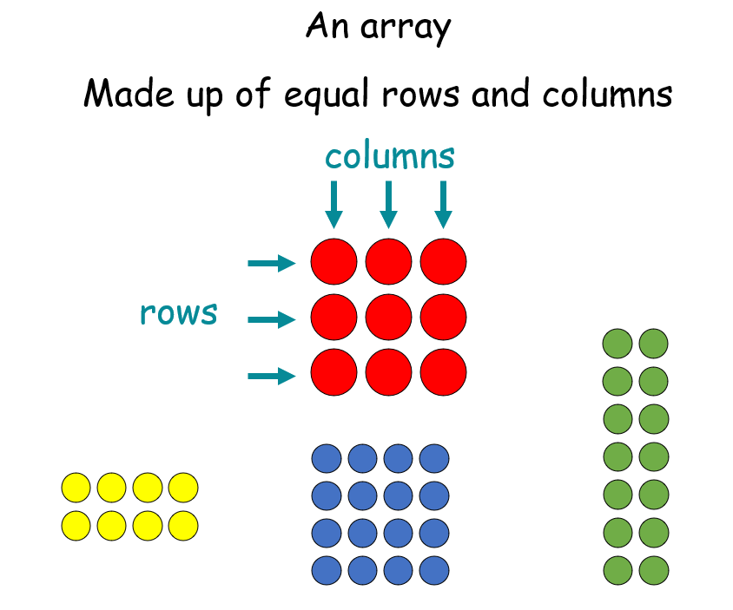
Using arrays:

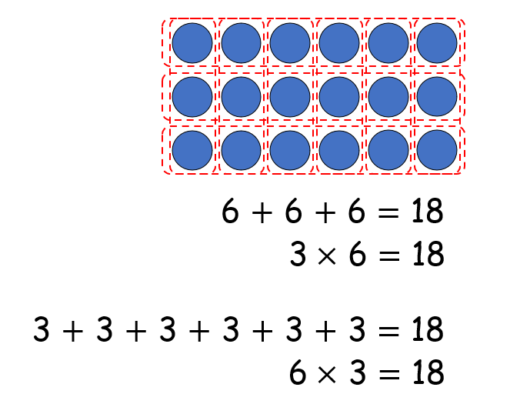
For example:

The multiplication symbol ‘x’ means:
- Lots of
- Groups of
- Times
3 lots of 6 is equal to 18
3 groups of 6 is equal to 18
3 times 6 is equal to 18

Repeated addition and support children’s understanding:
6+6+6 = 18 3+3+3+3+3+3= 18
3x6 = 18 6x3= 18

