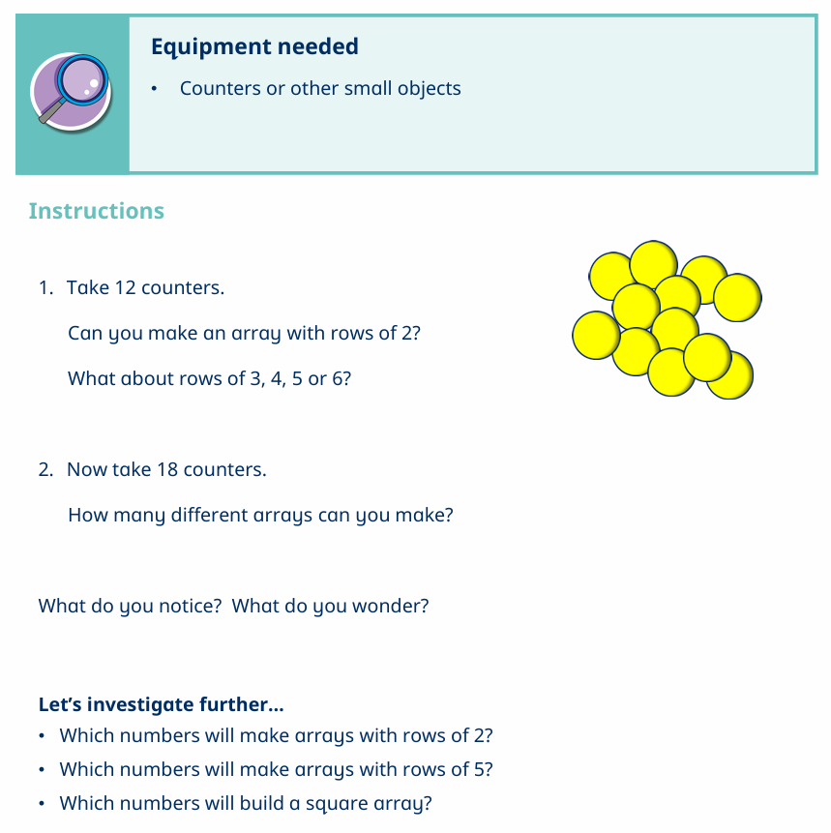
Array activities:

Dot Painting Arrays:
- Use paint, stamps, or just draw dots
- Make colourful arrays on paper:
  - 3 rows of 3 dots
  - 2 rows of 6 dots
Make it creative:
- Turn arrays into pictures (flowers, windows, robots )

Use small foods like grapes, raisins, pasta or smarties.
- Ask your child to arrange them into rows and columns
- Example: “Can you make 3 rows with 4 grapes in each row?”
- Then ask:
  - “How many altogether?”
  - “What if we turn it—does it change?”

