
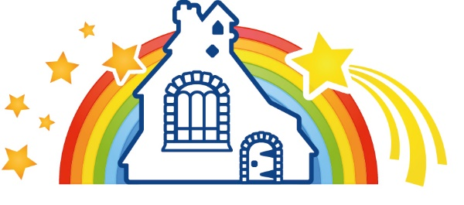

Shrivenham Pre-School Application Form

Please complete this form and return to preschool@shr.cambrianlt.org

Applications will be dealt with on a first come, first served basis.

Full name of child | Date of birth of child | Gender

Name(s) and address(es) of parents / carers making the application

Name:  Relationship to child:  Address:  Postcode  Tel. |  | Name:  Relationship to child:  Address:  Postcode  Tel.

Email address:

Please provide the following information:

When would you like your child to start (September, January or April)? If other, please state:

Session Options |  |  | Tick the option you would like
15hrs |  |  | Tick the option you would like
Option 1 | 5x morning sessions | Monday to Friday  8.30am-11.30am
Option 2 | 5x afternoon sessions | Monday to Friday  12.05pm – 3.05pm
Option 3 | 2.5 days (start of the week) | Monday and Tuesday  8.30-3.05pm (35 minutes payable lunch)  Wednesday 8.30-11.30am
Option 4 | 2.5 days (end of the week) | Wednesday 12.05pm-3.05pm  Thursday and Friday  8.30-3.05pm (35 minutes payable lunch)
3 days (18hrs) and 2 days (12hrs)
Option 5 | 3 days (consecutive) | Monday Tuesday and Wednesday  8.30am-3.05pm (with a 35-minute payable lunch)  OR  Wednesday, Thursday and Friday  8.30am-3.05pm (with a 35-minute payable lunch)
Option 6 | 2 days (consecutive) | Monday and Tuesday  8.30am-3.05pm (with a 35-minute payable lunch)  OR  Thursday and Friday  8.30am-3.05pm (with a 35-minute payable lunch)
30hrs
Option 1 | 5x morning plus 5 x afternoon sessions | Monday to Friday 8.30am – 3.05pm (with a 35-minute payable lunch)

Children staying all day do need to bring a packed lunch with them.

Children staying all day will have a £3 charge to cover the 35-minute lunch that is not covered by the Early Years Funding.

FUNDING INFORMATION – this is required if you wish to use the Early Years Funding to pay for sessions. 3-year-olds are funded automatically the term after their 3rd Birthday (Jan/April/Sept)

Funding Code:
Parent’s National Insurance Number:
Date of Birth of Parent:
(This is required to enable us to claim your child’s funding from Oxfordshire County Council)

FEES

2-year-old sessions - £6.50 per hour

3-year-old sessions - £5.50 per hour

Invoices are issued through ParentPay (our cashless online system) as per the payment schedule detailed below. Payments received after this date will incur a £25.00 administration fee. Full terms and conditions can be found at the end of this policy.

Full fees are still payable for any periods of absence due to illness and holidays which are taken during term time.

Costs do not include nappies, pull-ups, snacks, sun-cream, trips and visits.

Tick to confirm:
I can confirm that I have read and understood the Pre-School Admissions Policy
I can confirm that I have read and understood the Terms & Conditions
I agree to adhere to the Booking & Payment Schedule and understand that failure to do so may result in additional charges being made and/or the withdrawal of my child’s place at Shrivenham Pre-School.

Signature of parents / carers: ________________________________________________

Name of parent/carers: _____________________________________________________

Date: ________________________________________

Office use only

Date application received: _________________________________ Staff Initial: ________________

