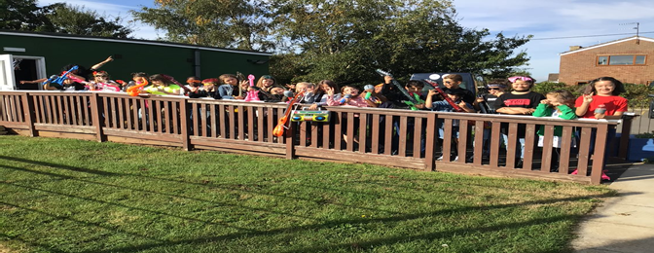
Rockstars Day at Shrivenham
Last Friday a range of Rockstars came to our school to take part in our launch of Times Table Rockstars. It was fabulous to see all the children dressing up as stars like David Bowie, Elvis, Cher amongst many others. After an assembly where the whole school sang to Queen’s ‘We Will Rock You’, everyone returned to their classes, where the children had the opportunity to log onto the Times Table Rockstars website.
At lunchtime the fun continued with Cher hosting an outdoor disco. Many children came and requested their favourite songs and there was a great sing-a-long.
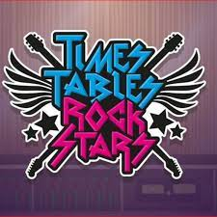
The purpose of the day was to introduce Times Table Rockstars, an online programme for the children to learn and practise their multiplication tables. We will be completing a paper version of the programme everyday in class and the children will be able to record their progress at the end of every term.
Homework
As you are aware, this year we have changed our homework policy. This means that your child will not be bringing maths sheets home to complete. Instead, we want them to spend 10 to 15 minutes, 3 times a week on the Times Table Rockstars site. The programme automatically assesses and set the appropriate table for each child to practise. As they complete the different stages, the child’s rock status changes. In school we will be awarding certificates each week to the children in each class who have earned the most coins and these will be presented in celebration assembly.

All children in Years 2, 3, 4, 5 and 6 have been given a password and login details, which we shared with you last Friday. If you have any problems with the website, please contact us. The school website contains a parents guide explaining the different levels and the different games. Year 1 will not begin to use Times Table Rockstars until after Christmas.
We all had a great day on Friday and are very excited about our first set of certificates!

We

