
Developing Writing
Multisensory learning: using different senses to support writing
- 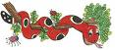Jolly phonic actions – an action for each phoneme and some digraphs etc.
- Songs- use a range of nursery rhymes, made up rhymes and Jolly phonic songs.
- 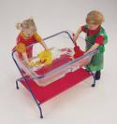Sounds in the water/sand tray-use to build up words/sound recognition.
- 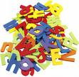Magnetic and wooden letters
- 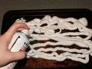Letters in shaving foam, gloop, paint, salt, flour etc.
- 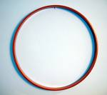Forming round letters using hoops
- 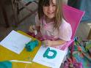Playdough letters, cookies- cutting out letters
- 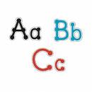Join the dots- joining dots to form letters.
- 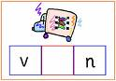Box writing- using boxes to help the child know where to write each letter.
- 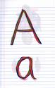Rainbow writing- writing over and over a letter to encourage letter formation.
- 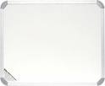Whiteboard writing- to encourage independent writing-all mistakes can be easily wiped away.
- 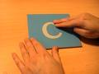Sand paper letters- to encourage letter formation
- 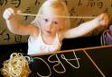Writing with spaghetti, pipe cleaners etc.- another way of forming letters.
- Pastels, chalk, paint, glue etc.- writing using different mediums adds interest.
Planning writing:
- Sequencing ideas: post it notes, dry wipe boards, mind maps, pictures, bullet points

Using different ways of recording: Pupils can demonstrate their knowledge in a range of ways for example:
- Diagrams
- Presentations
- ICT, computers, Dictaphones
- Video
- Story boards

Pencil control/ handwriting


- Copying shapes and line
- Dot to dots or mazes
- Word searches
- Colouring in
Highlighting lines to aid in writing size


