
Developing Memory
Here are a few activities to support memory
- Use cue cards for reminders
- Display flow charts
- Use visual timetables, checklists and prompts
- Post it notes
- Use colour to organise work
- Use pictures to support memory e.g when writing lists draw pictures next to the items.

Rehearsal
Verbal repetition of items/ words to remembered, repeated over and over

Categorisation:
Grouping items into categories

Chucking:
e.g. to remember a phone number group digits into groups of two or three.

Visualisation
e.g. to remember lists, information etc. The individual could make up a story for example I went for a walk down the street, on the way I saw an elephant carrying some bananas who was standing under an apple tree. The elephant waved hello and passed me a carton of orange juice.

This principle can be added to other work such as remembering the sequence of a story. Actions can also be added in order to reinforce the concept.

I went shopping and I bought or in my suitcase I put- the list should gradually get longer.

Instruction game:
Give a range of silly commands to be completed, this list should gradually get longer e.g. crawl under the table, turn around and put a book on your head.

Children could be asked to draw something e.g. draw a house with blue windows and a red door.
Simon says

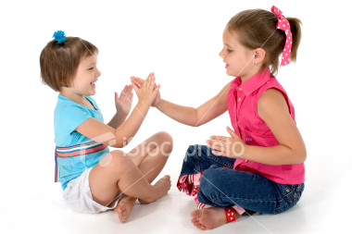
Tell a story where children must complete actions at certain words within the story.

Songs and rhymes
See Sing up. Co. uk

Clapping games

Kim’s game
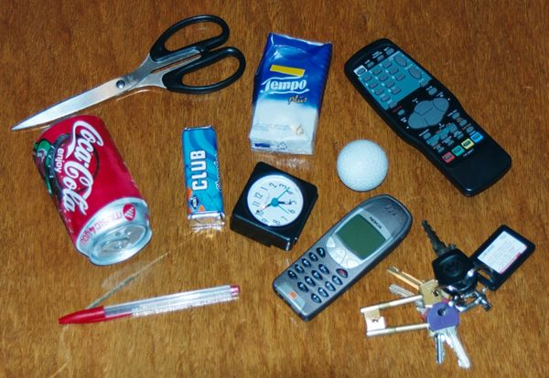
Put a selection of items on a tray allow one minute for the child to look at the items then cover them over. Remove an item and ask the child to remember which is missing. Gradually increase the number of objects.

Card games
e.g. snap, pairs, rummy

Copying patterns
Using bead strings, lego, building blocks etc.

Show the individual a picture, remove it and ask the child to describe it in detail.



